New Product(s) Submission to Jury

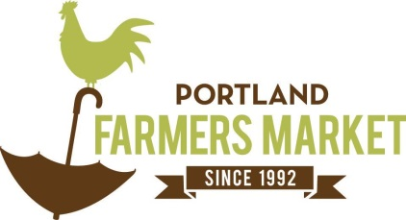PFM is a farmer focused organization that takes pride in the unique and quality food items sold in its markets. Product jury is an important part of our process to determine which products best fit in our market. Please turn this paperwork in with a sample of your product(s).

Vendor Name_____________________________________________

Date ____________________________________________________

Vendor Checklist for Jury

Product in final sale packaging (or if not finalized, a description of intended packaging)

Legal requirements labeled such as net weight and ingredients

At least 25% of raw ingredients are purchased directly from local farms

Ingredient sourcing form included

Product(s) Name, Description and Price

1. _____________________________________________________________________________
2. _____________________________________________________________________________
3. ­­­­­­­­­­­­­­­_____________________________________________________________________________
4. _____________________________________________________________________________
5. ­­­­­­­­­­­­­­­_____________________________________________________________________________

How/where produced: _________________________________________________________________

Where your products are sold (states, stores, markets): _______________________________________

Allergen/Health Claims: ________________________________________________________________

Add additional information or stories about your product(s)

____________________________________________________________________________

____________________________________________________________________________

____________________________________________________________________________

____________________________________________________________________________

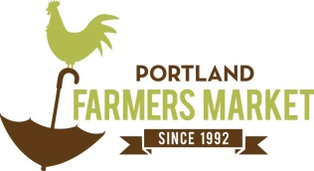Ingredient Sourcing Form

Vendor Name____________________________ Date___________________

|  |  |  |  |
| --- | --- | --- | --- |
| Menu Item or Product (add all flavors) | List all product Ingredients  **Check ingredient if**  **farm direct** | List all product Ingredients  **Check ingredient if**  **farm direct** | Farm Source(s) for raw ingredients |
| 1. |  |  |  |
|  |  |  |
|  |  |  |
|  |  |  |
|  |  |  |
|  |  |  |
| 2. |  |  |  |
|  |  |  |
|  |  |  |
|  |  |  |
|  |  |  |
|  |  |  |
| 3. |  |  |  |
|  |  |  |
|  |  |  |
|  |  |  |
|  |  |  |
|  |  |  |
| 4. |  |  |  |
|  |  |  |
|  |  |  |
|  |  |  |
|  |  |  |
|  |  |  |
| Notes: | | | |

Instructions:

* List different menu items/products in each numbed box. Include all flavors offered and indicate if seasonal/rotating in numbed box.
* Record all ingredients including separate flavor additions. Put a check mark next to ingredients that are sourced directly from a farm (not including distributors).
* List all farms you directly purchase from and their contact for sourcing verification.

*if you need help finding farms, reach out to PFM before you turn in your ingredient sourcing form.